2018-19
Best practice I

Title of the practice: Cleaning of the college campus

Objectives of the Practice:

To continue to keep the camp clean and tidy and as done in the last year still value the dignity of labor and working together with the students

The Context:

This college is situated in an area of 12 Acres. It has 250 trees and other foliage. Thus, there is yet a lot of plant wastage in the forms of leaves and wood.

The Practice:

The process begins generally in July/ August with the start of the academic year. The strength of the team is 100 students composed of 50 NSS students and 50 freshers on rotational bases. The students are asked to take out weeds and other waste material. This biodegrade material is dumped into a pit of 100 cubic feet. This is left to decompose into organic manure. This process is done once a week on Saturday from 10 am to 11 am. The entire gamut of this exercise is led by the NSS coordinator and other faculty on rotation.
This exercise has made a distinct impact on the cleanliness of the camp, as also on the ability of students to work in team spirit.
Evidence of Success:

This initiative has created an ambiance of positive involvement in the students and staff alike.

Problems Encountered and Resources Required:

No major problems were encountered. The small requirements of brooms/ spades and other pruning materials were provided by the college.
CLEANING CAMPUS
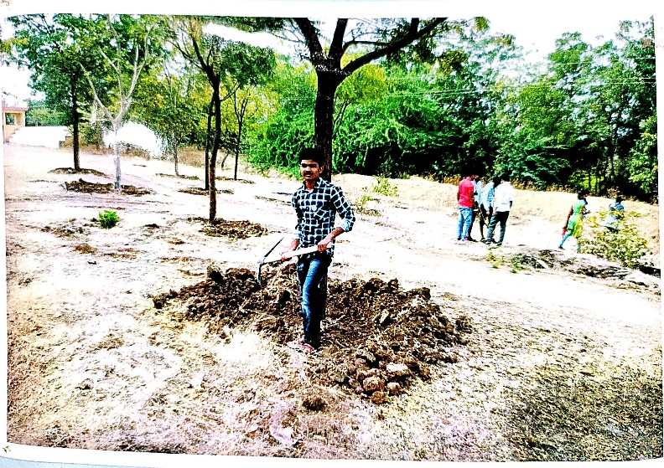
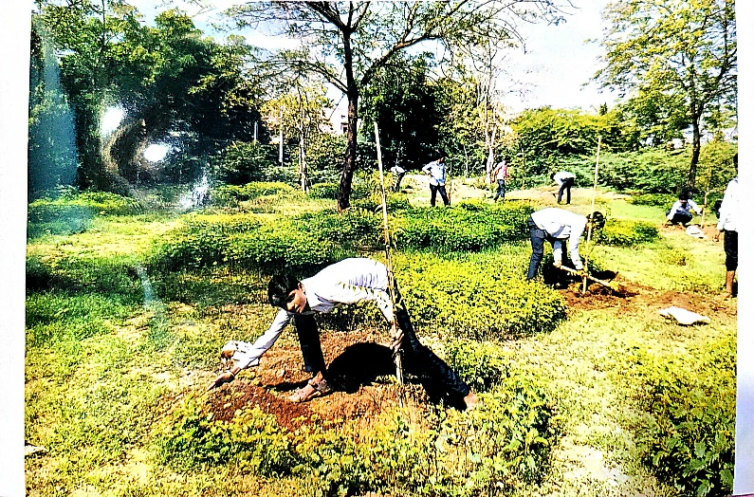

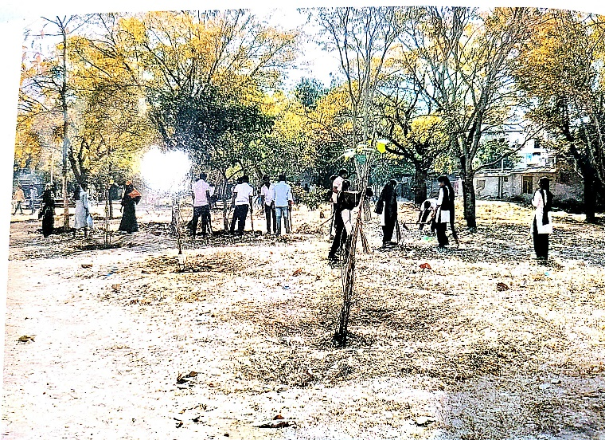
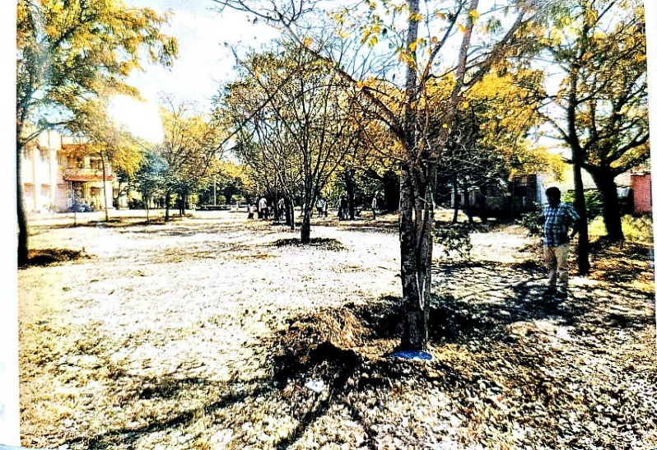

2018-19
Best practice II

Title of the Practice: Tree plantation

Objectives of the Practice:

To continue to keep alive the environmental consciousness on 12 acres of campus Which provides enough space for tree plantation, and which can make the campus green and pollution-free.

The Context:

With the help of the Forest Department, the college wanted that some action to be taken to increase green coverage on the campus and had identified space for additional tree plantation.

The Practice:

The team sought the help of the department of forestry and they felt that at present planting needs would be of great ease and help. Thus 50 neem trees were planted during June/July 2018-to 19

Evidence of Success:

20 neem and more are other plants that have been planted by the students on a college campus. Now we are hoping that after this rainy season, these planted trees will provide us with feelings of happiness. The Forest department suggested that we should take slightly grown-up sampling having a height of about a meter. This suggestion was accepted. The digging of soil and its preparation was undertaken by the students.

Problems Encountered and Resources Required:

The following problems were encountered
- Shortage of piped water for each tree.
- Guards/ protection through barbed wire to the saplings as fencing.
These issues have been discussed with the Principal. The cash has prohibited in having fencing.

